STUDENT WORKSHEET

Aim

Create a Student Worksheet for 10 students with Roll No., Name, Department, Marks (M1, M2, M3, M4, M5). Calculate the Total and Grade. If Total marks >= 350 Grade A, total marks < 350 and >= 200 Grade B, total marks < 200 Grade C.

Template

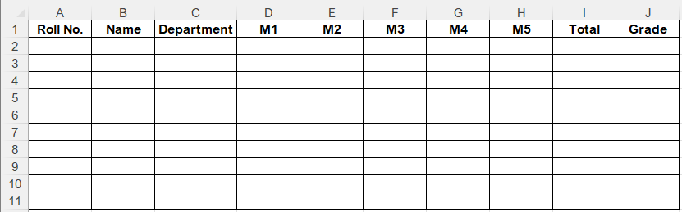

Implementation Formula

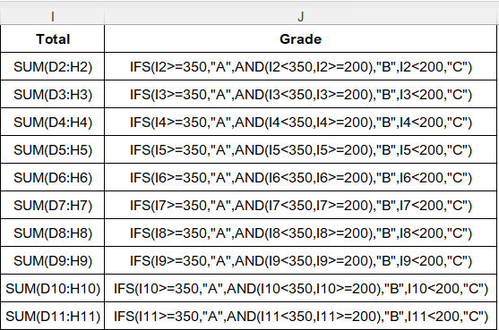

OUTPUT

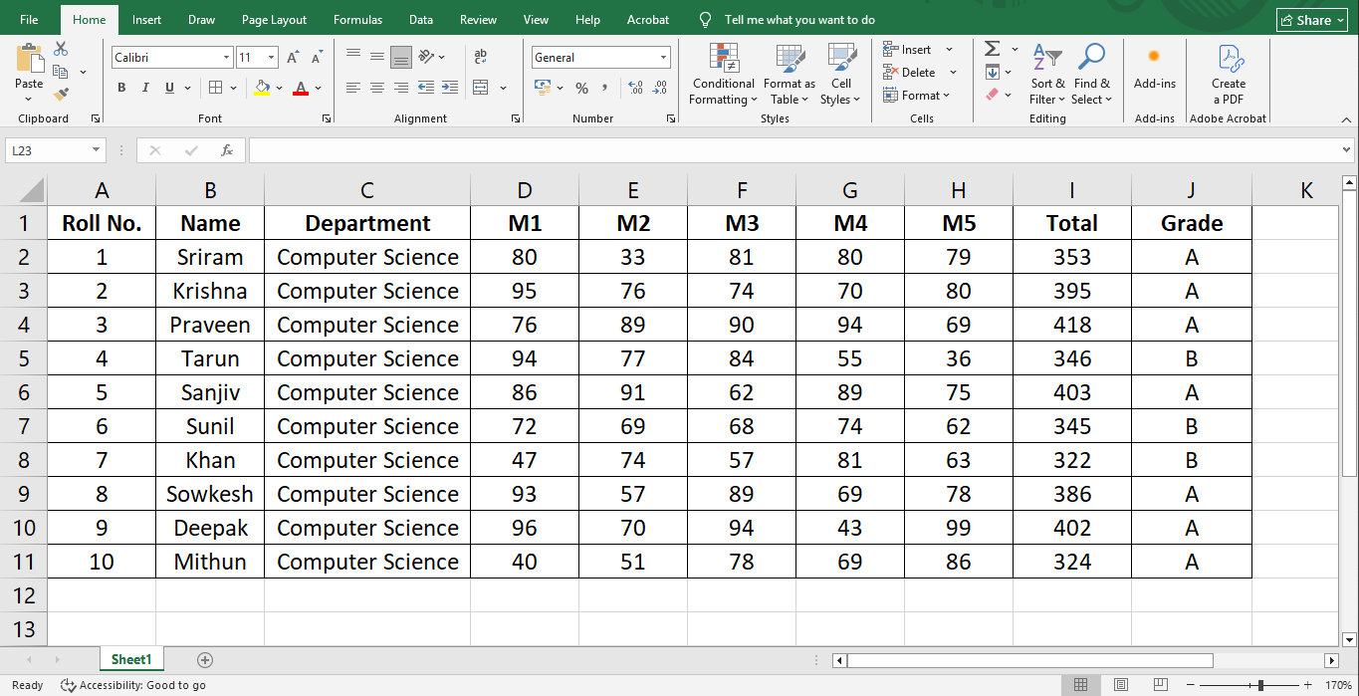

Result
Thus, a student worksheet has been created for grade calculation based on the given criteria.

EMPLOYEE WORKSHEET

Aim

To create an Employee Worksheet with Basic Salary and calculate HRA, DA, Total Salary. HRA = 24% of Basic Salary, DA = 35% of Basic Salary, Total Salary = Basic Salary + HRA + DA

Template

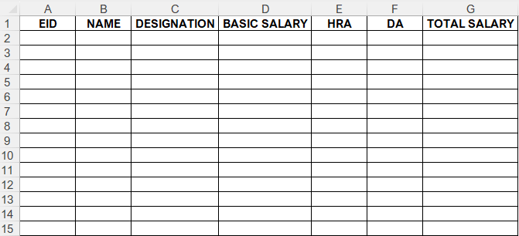

Implementation Formula

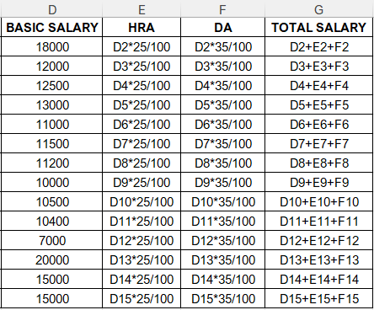

OUTPUT

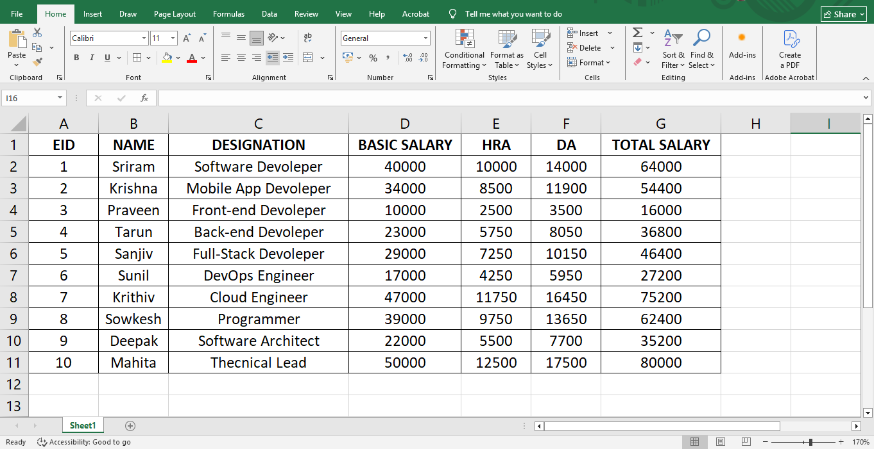

Result
Thus, an employee worksheet has been created and the total salary has been calculated successfully.
STORE WORKSHEET

Aim
To create a Store Worksheet with Item number, Item name, Quantity, Price. Calculate the Amount. (Amount = Quantity*Price).

Template

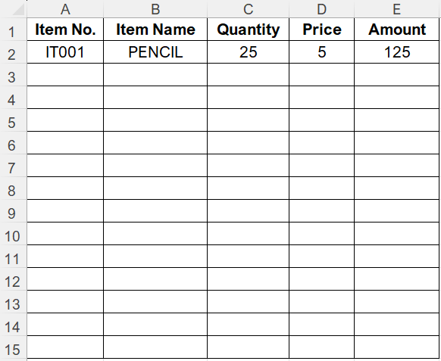

Implementation Formula

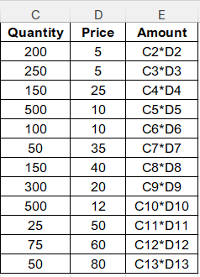

OUTPUT

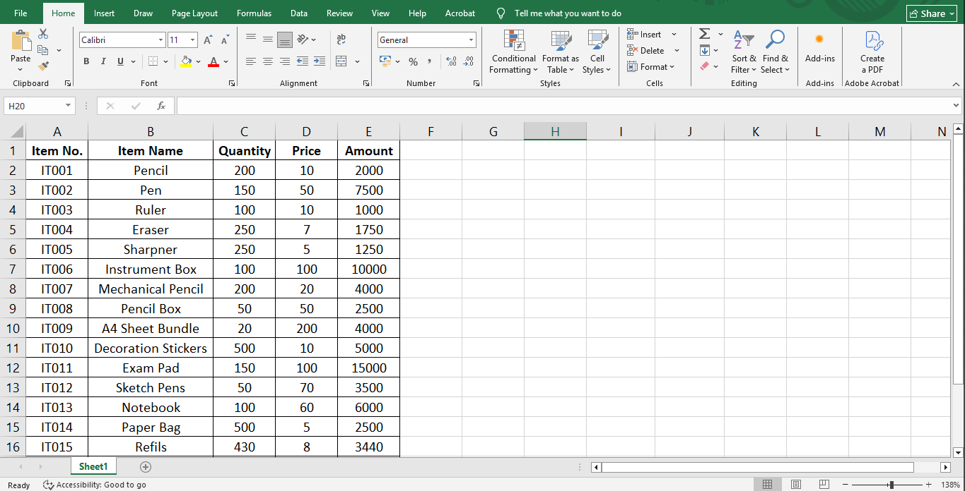

Result
Thus, the store worksheet has been created and the amount is calculated using the formula, and the output verified successfully.

SPORTS WORKSHEET

Aim
To create a sports worksheet for your favourite outdoor game and analyze game results using a column chart, line chart & pie chart

Template

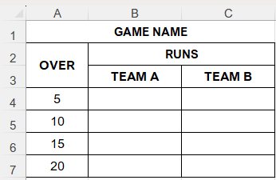

DATA

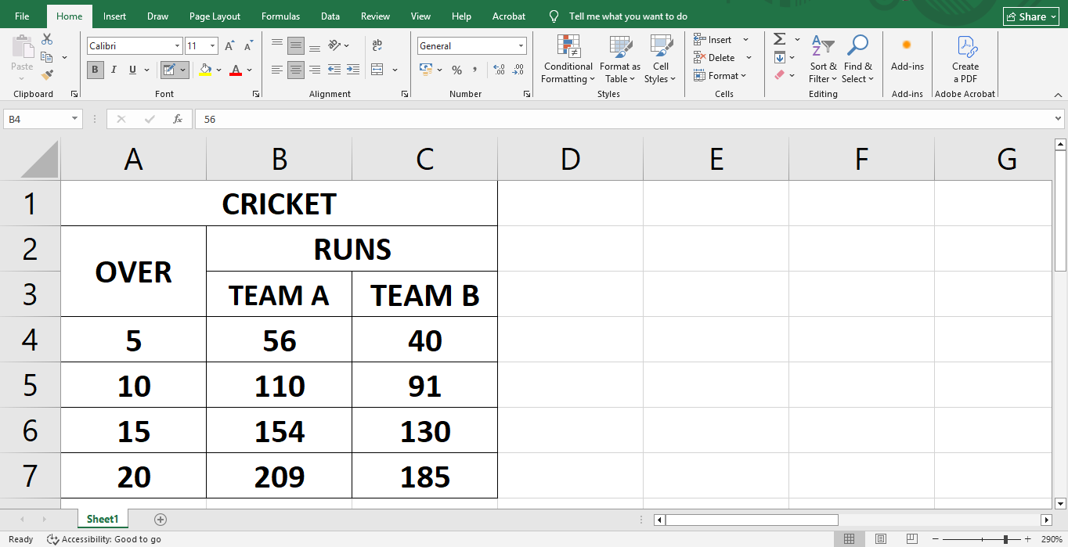

OUTPUT

Result
Thus, the store worksheet has been created and the amount is calculated using the formula, and the output verified successfully.

